**Registration#__________________**

University of Engineering & Technology Lahore

Experiment # 4

Title: Z Transform-I

Equipment Required: Personal computer (PC) with windows operating system and MATLAB software

Theory:

Z transform is an important tool for the analysis and design of discrete time signals. It transforms a signal of time domain into a function of variable z. For discrete time signal x(n), z transform is defining as,

$$X\left[Z\right]= \sum_{n=-∞}^{∞}{x[n]Z^{-n}}$$

The properties of the z-transform are generalizations of the properties of the discrete-time Fourier transform.

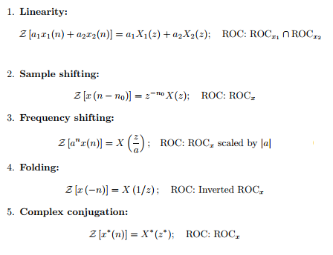

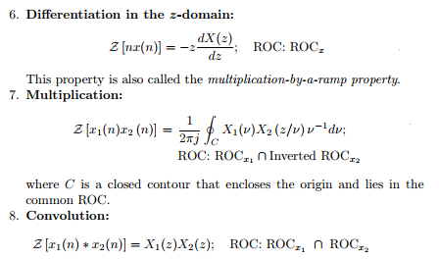

Example 1:

Find z transform of $x(n)= (1/4)^{n} u(n).$

$$>> syms z n$$

$$>> ztrans ({\left(\frac{1}{4}\right)}^{n})$$

Task1:

$x(n)= (1/4)^{n} u(-n).$

$x(n)= ({0.8)}^{n} u(-n-1).$

$x(n)= (4^{n}) u(1-n).$

$x(n)= (n+1)(3^{n-2}) u(n).$

$x(n)= nSin(πn/3) u(n)+ ({0.9)}^{n} u(n-1).$

1. Find out the answers of the questions above on paper.
2. Verify your answers using MATLAB.

Task2:



Verify result using convolution property.